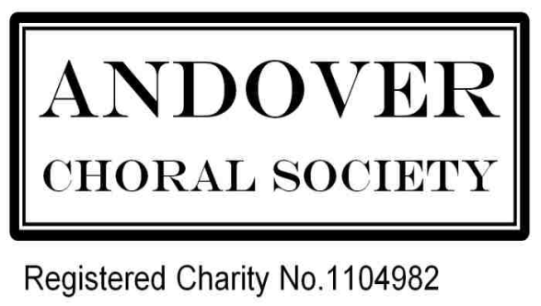

1. Title. The Society shall be known as "THE ANDOVER CHORAL SOCIETY." In these Rules it is referred to as “the Society”.
2. Object. The object of the Society shall be the study and practice of choral music in order to foster the public knowledge and appreciation of such music by means of public performance and to engage in any activities as shall further this object.
3. Membership. Membership shall be open, at the discretion of the Committee, to any person who is able to satisfy the Director(s) of Music of his or her singing ability. New Members may be required to serve a probationary period.
4. Attendance. Members shall maintain regular and punctual attendance at rehearsals. Attendance shall be recorded by the Stewards (see para 13 below) and if, in the opinion of the Committee, a Member has not attended sufficient rehearsals, he or she may be excluded from the associated performance.
5. Subscriptions. “Season” refers to the whole 12-month period between AGMs. The annual subscription shall be determined by the Committee, based on the Treasurer’s advice, and presented to members for their approval at the Annual General Meeting. Subscriptions shall be fully paid up within the first 3 months of the date of the first rehearsal in each season and may be paid by instalments across the first 3 months, so that the full amount is paid by the first concert of the season. Members in arrears may be barred from rehearsals or performances until subscriptions have been paid. Those new Members who join after the first concert of the season shall pay 50% of the annual subscription for the remainder of that season. If members wish to pay in advance for the following season by regular payment, they should speak to the Treasurer so that accurate records can be maintained of their pre-payments. Should a member be in credit with the Society, upon leaving or for other good reason, any sums paid in advance for the following season will be returned to them or their authorised representative (i.e. executor).
6. Funds. The funds of the Society shall be applied solely to the object stated in Rule 2. In the event of dissolution any remaining funds shall be devoted to similar objects or to other purposes approved by the Members.
7. Music. Members are encouraged to provide their own music. When they are unable to do so, and there is sufficient demand, the Society will borrow scores from a recognised library and loan them to Members at a reasonable rate.
8. Annual General Meeting. An Annual General Meeting shall be held immediately prior to the commencement of each season, normally in the month of September. The meeting shall be convened by the Secretary, who shall give Members at least fourteen days’ notice in writing of the time and place of the meeting and of the proposed Agenda. At the Annual General Meeting a properly audited Balance Sheet for the preceding year shall be presented to the Members by the Treasurer. Officers and Stewards for the ensuing year will either be confirmed in post or elected to fill identified vacancies; written nominations for vacant posts shall reach the Secretary seven days before the date of the Annual General Meeting.
9. Special General Meetings. A Special General Meeting may be convened by the Committee at any time, either to present matters for the Members’ consideration that cannot wait until the next Annual General Meeting or upon receipt of a request signed by at least fifteen Members of the Society; any such request shall state the exact business to be discussed, and no other business shall be considered at the associated Special General Meeting.
10. Quorums. At Annual and Special General Meetings, twenty Members shall constitute a quorum. At Committee Meetings, five Committee Members shall constitute a quorum.
11. Director(s) of Music. The Director(s) of Music shall be confirmed in post or appointed by the Membership at the Annual General Meeting. The Director(s) of Music shall, ex officio, be non-voting members of the Committee. The Director(s) of Music shall advise the Committee with regard to the selection of music to be performed, the Artists to be engaged and the appointment of the Accompanist(s).
12. Officers. The Officers of the Society shall be:
Chairman Publicity Secretary
Secretary Sponsorship/Patrons Secretary
Treasurer Social Secretary
Registrar Librarian

The Chairman, Secretary and Treasurer may not hold their appointments for more than 5 years and other Officers are encouraged to follow the same rule.

13. Each voice section (soprano, alto, tenor and bass) shall be represented by a Steward who will be responsible for the needs and interests of their relevant section.

14. Committee of Management. The Committee of Management ( “ The Committee “ ) shall consist of the Director(s) of Music (Rule 11), the Chairman, the Secretary, Treasurer, Registrar, and the Stewards (Rule 13) The Chairman may, on behalf of the Committee, co-opt other Officers of the Society to attend specific Committee meetings as required. The Committee shall be responsible for the choice of the works to be performed, the artistes to be engaged, financial and other arrangements and for all matters connected with the management of the Society and shall have the power to deal with any matter arising from, or not met by, these Rules.

15. Revision of Rules. Any proposed alteration or addition to these Rules must be sanctioned by a majority vote at an Annual or Special General Meeting.

